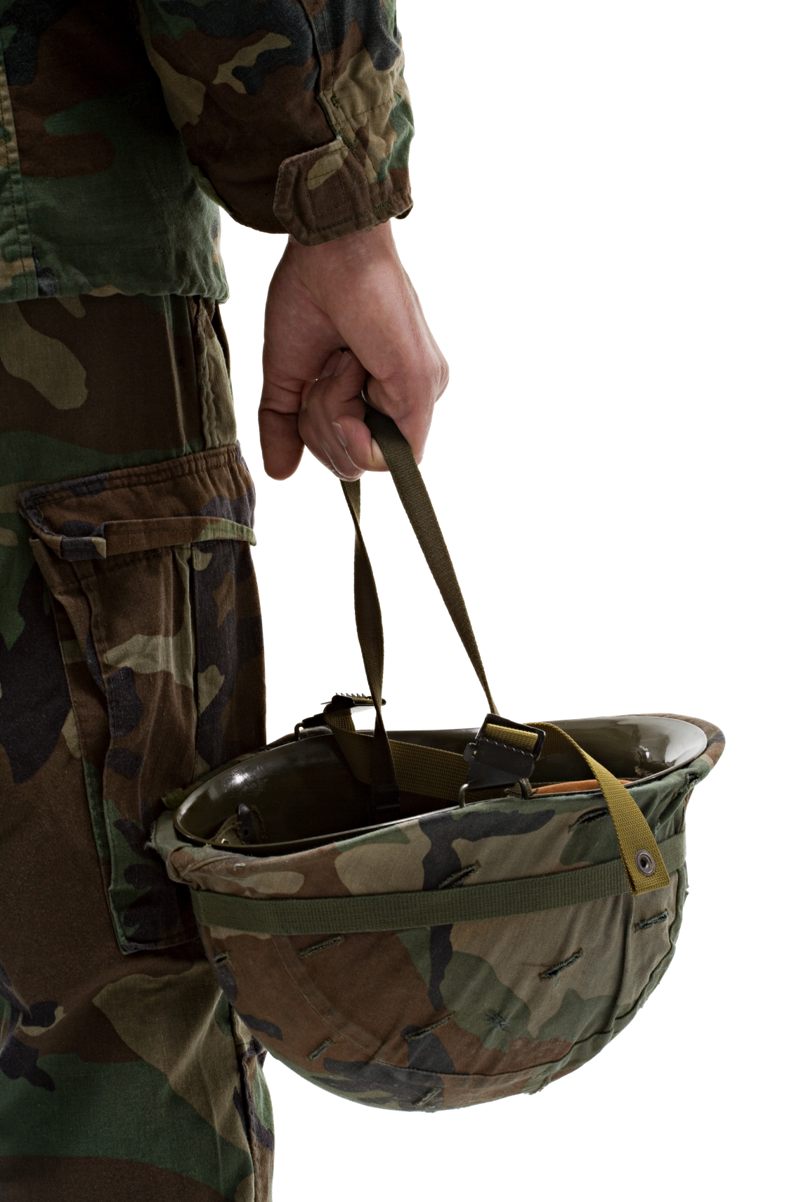

U

**JOIN US IN SUPPORTING THIS VETERANS**

**MONUMENT HONORING ALL VETERANS OF ALL WARS**

# Sponsorship Opportunities

## VETERANS LEGACY SPONSOR - $50,000 (Sponsorship taken)

*On behalf of the*

*Placer County Veterans Monument,*

*we cordially invite you to join us for a Veterans Day Ceremony at McBean Park in Lincoln, California, Nov. 11, at 11:11 a.m.*

November 11th, 2020 dedication ceremony title sponsor Name at top of sponsorship, social and media materials Name at top of permanent donor monument

**SPONSORED**

Reserved seating and recognition at dedication ceremony

Logo prominent on event coalition website and ceremony program Identified as Veteran Legacy Sponsor on press release issued by PCVM Dedicated social media posts

## FREEDOM SPONSOR - $25,000 (2 AVAILABLE)



Name on sponsorship, social and media materials

Name on permanent donor monument

Reserved seating and recognition at dedication ceremony Logo on event coalition website and ceremony program

Identified as Freedom Sponsor on press release issued by PCVM Dedicated social media posts

## REMEMBER A VETERAN SPONSOR - $10,000 (2 of 5 AVAILABLE)

Name on sponsorship, social and media materials

Name on permanent donor monument

Logo on event coalition website and ceremony program Dedicated social media posts

Option to sponsor water or soft drinks (Choose one: ) Identified as Remember a Veteran Sponsor on press release issued by PCVM

## PATRIOT SPONSOR - $5,000 (2 of 10 AVAILABLE) SUPPORTING SPONSOR - $1,000 (NO LIMIT)



Name on sponsorship, social and media materials Name on permanent donor monument

Logo on event coalition website and ceremony program Dedicated social media posts

Name on permanent donor monument Supporting sponsor listed in ceremony program Dedicated social media post

## PRIVATE DONATION SPONSOR - $

# Sponsor Information

Company: Contact: Mailing Address: City: State: Zip:

Phone: Email**:**

**Please mail this sponsorship form with payment to**:

Treasurer | Placer County Veterans Monument   
PO Box 867, Lincoln, CA  95648

**Make checks payable to: Placer County Veterans Monument**  
 [**email to:** PlacerCountyVeterans@gmail.com](mailto:%20email%20to:%20PlacerCountyVeterans@gmail.com) or call (530) 812-0376  
[www.PlacerCountyVeteransMonument.org](http://www.PlacerCountyVeteransMonument.org)

Lincoln Veterans Memorial Coalition, 501(c)(3) Non-Profit EIN: #83-0539608